STAT364 (Ref: Lecture 6 – 8, Chapter: 19, 20, 24) ASSIGNMENT – 2
Mürüvvet Eda Koyuncu
2561413

Assigned Date: 02.05.2025 Due Date: 23.05.2025

The data below includes data from individual who participated in a survey. The variables include the following:

AGE: Age (years)
GENDER: Gender (Male, Female)
REGION: Region (Europe, Asia, Africa, America, Other)
MSTAT: Marital Status (Single, Married, Divorced, Widowed)
EDUL: Education Level (School, College, Graduate, Post Graduate)
HOURS: Working Hours (weekly)

-------------------------------------------------------------------------------------------------------------------------------------------------------------
Problem: Analyze the data using R-functions mentioned in each of the following Sections. Report the corresponding outputs with proper Comments in your own words that include short Explanation, Interpretation of the results, conclusion, etc. Also provide the R-scripts that you have created and invoked to get the corresponding outputs.
-------------------------------------------------------------------------------------------------------------------------------------------------------------

- Read the data from data file ‘data.csv’ (uploaded on ‘ODTUCLASS’) and print first 10 and last 10 rows of the data. Report total number of participants in the survey. [R-functions: read.csv( ), head( ), tail( ), dim( ), print()]

Output:

First 10 rows:
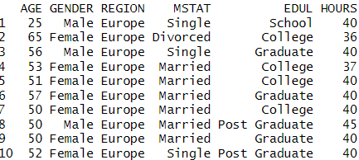

Last 10 rows:
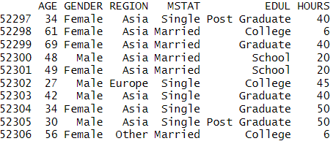

Total Participants: 52306

R-script:
data <- read.csv(file.choose())
head(data, 10)
tail(data, 10)
dim(data)[1]

The dataset's top ten rows are shown via the Head() function. This provides a brief overview of variable values and aids in confirming that the data was read accurately.
- Extract each variable individually from the dataset and print first 5 values for such variables. Also report the mean and variance of the participant’s ages and the working hours. [R-functions: mean( ); var( )]
Output:
First 5 values:

AGE : 25 65 56 53 51
GENDER: “Male” “Female” “Male” “Female” “Female”
REGION: "Europe" "Europe" "Europe" "Europe" "Europe"
MSTAT : "Single" "Divorced" "Single" "Married" "Married"
EDUL : "School" "College" "Graduate" "College" "College"
HOURS : 40 36 40 37 40

Mean, Variance:

AGE : mean=44.55003
variance=147.2579
HOURS : mean=40.54976
variance=124.6691
R-script: head(data$AGE, 5)
head(data$GENDER, 5)
head(data$REGION, 5)
head(data$MSTAT, 5)
head(data$EDUL, 5)
head(data$HOURS, 5)

mean(data$AGE)
var(data$AGE)

mean(data$HOURS)
var(data$HOURS)

- Covert the data in each of the following variables (call them FACTORS) into Codes (Labels). Print codes with corresponding frequencies for each of the FACTORS. [R-functions: table( )]

AGE : 1 ($≤$ 35 years), 2 ($>35$ and $≤60$ years), 3 ($>60$ years)
GENDER : 1 (Male), 2 (Female)
REGION : 1 (Europe), 2 (Asia), 3 (Africa), 4 (America), 5 (Other)
MSTAT : 1 (Single), 2 (Married), 3 (Divorced), 4 (Widowed)
EDUL : 1 (School), 2 (College), 3 (Graduate), 4 (Post Graduate)

[Hint: For example to assign Code 1 to AGE $≤$ 35 years use R-function: AGE[AGE <= "35"] = 1 and so on…]

Output:

AGE: Code: 1 2 3
Frequency:14369 32229 5708

GENDER: Code: 1 2
Frequency: 26238 26068

REGION: Code: 1 2 3 4 5
Frequency: 41242 4043 5546 655 820

MSTAT: Code: 1 2 3 4
Frequency: 10281 34363 6681 981

EDUL: Code: 1 2 3 4
Frequency: 5547 19376 16793 10590

R-script: AGE_CODE <- data$AGE

AGE_CODE[AGE_CODE <= 35] <- 1
AGE_CODE[AGE_CODE > 35 & AGE_CODE <= 60] <- 2
AGE_CODE[AGE_CODE > 60] <- 3

GENDER_CODE <- data$GENDER
GENDER_CODE[GENDER_CODE == "Male"] <- 1
GENDER_CODE[GENDER_CODE == "Female"] <- 2

REGION_CODE <- data$REGION
REGION_CODE[REGION_CODE == "Europe"] <- 1
REGION_CODE[REGION_CODE == "Asia"] <- 2
REGION_CODE[REGION_CODE == "Africa"] <- 3
REGION_CODE[REGION_CODE == "America"] <- 4
REGION_CODE[REGION_CODE == "Other"] <- 5

MSTAT_CODE <- data$MSTAT
MSTAT_CODE[MSTAT_CODE == "Single"] <- 1
MSTAT_CODE[MSTAT_CODE == "Married"] <- 2
MSTAT_CODE[MSTAT_CODE == "Divorced"] <- 3
MSTAT_CODE[MSTAT_CODE == "Widowed"] <- 4

EDUL_CODE <- data$EDUL
EDUL_CODE[EDUL_CODE == "School"] <- 1
EDUL_CODE[EDUL_CODE == "College"] <- 2
EDUL_CODE[EDUL_CODE == "Graduate"] <- 3
EDUL_CODE[EDUL_CODE == "Post Graduate"] <- 4

table(AGE_CODE)
table(GENDER_CODE)
table(REGION_CODE)
table(MSTAT_CODE)
table(EDUL_CODE)

- Consider a Linear Model with Response Variable $Y$: Working Hours (HOURS) and Factor AGE with the 3 Levels (1, 2, 3). Perform the ANOVA and report the results. Is there something wrong about the degrees of freedom as reported for AGE in the ANOVA output? Explain why it is so? [R-functions: lm( ), aov( )]
Output:
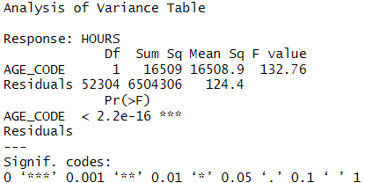

Comments: In the ANOVA output above, AGE_CODE has only 1 degree of freedom, which is incorrect. Since AGE_CODE was intended to represent a 3-level categorical factor, it should have 2 degrees of freedom (k − 1 for 3 groups). This error occurred because R interpreted AGE_CODE as a numeric variable, not a factor. As a result, the model treated AGE_CODE as a continuous predictor and performed a simple linear regression instead of a proper one-way ANOVA.To resolve the issue, AGE_CODE must be converted to a character or factor before modeling. Once corrected, R will appropriately treat it as a factor, and the ANOVA will show the correct 2 degrees of freedom and compare the group means as intended. The ANOVA table initially showed that AGE_CODE had only 1 degree of freedom and a highly significant p-value (p < 2.2e-16), a significant relationship between age and working hours.However, the degrees of freedom are a critical diagnostic indicator here. The variable AGE_CODE was supposed to represent a factor with 3 levels, which should result in 2 degrees of freedom (k – 1 = 3 – 1 = 2). The fact that only 1 df is reported signals a deeper issue.

R-script: model <- lm(HOURS ~ AGE_CODE,data = data)
anova(model)

- Being codes, the 3 levels of the Factor AGE should be of type ‘character’. Check for it by invoking R-function is.character and report the corresponding output and explain it?
If Levels are found not in ‘character format’ then change them to ‘character format’ and then perform the ANOVA.
See if the problem related with the degrees of freedom, faced in (d), is now resolved.
R-functions: is.character( ), as.character( )]

Output:

AGE Format: FALSE, “numeric”

ANOVA:
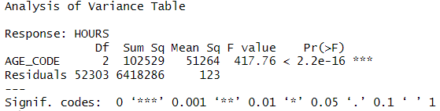

Comments:
The variable AGE_CODE was initially coded with the following numbers: 1, 2, and 3. Because of this, R mistook it for a continuous variable in the linear model, giving the ANOVA table only one degree of freedom. This is not true for a three-level categorical variable, which should have two degrees of freedom. We verified that AGE_CODE was not a character by using is.character() to check the type. We used as.character() to fix this. R appropriately handled it as a factor after conversion. As anticipated for three group levels, a rerun of the ANOVA revealed two degrees of freedom. This demonstrates that the previous degrees of freedom problem was caused by an improper variable type, and it has been fixed completely.
We first verified the data type of the AGE variable using is.character(AGE_CODE). The result was FALSE, indicating that AGE was not stored as a character variable, so we converted it using AGE_CODE<- as.character(AGE_CODE). This step is crucial because, for ANOVA to correctly recognize and compare between the three age categories, the AGE variable must be treated as a categorical factor. Once converted to character, we re-ran the linear model and ANOVA. The ANOVA output now correctly reports 2 degrees of freedom for AGE, corresponding to the three age groups, which confirms that the issue in part (d) was resolved.
The ANOVA results show that AGE has a statistically significant effect on the number of working hours reported by participants. The very high F-statistic (417.8) and extremely small p-value (< 2e-16) provide strong evidence that average working hours differ significantly between at least two of the three age groups. Moreover, the degrees of freedom for AGE are correctly reported as 2, indicating that the variable was properly interpreted as a categorical predictor in the model.

R-script: is.character(AGE_CODE)
AGE_CODE <- as.character(AGE_CODE)
model2 <- lm(HOURS ~ AGE_CODE,data = data)
anova(model2)

- Perform the ANOVA while using all Factors with all their Levels in a largest linear model (having all Main Effects and all Interaction Effects). Report the corresponding model selection criterion ‘AIC’ value.
[R-functions: lm( ), aov( ), AIC( )]

R-script: model3<- lm(HOURS ~ AGE_CODE * GENDER_CODE * REGION_CODE * MSTAT_CODE * EDUL_CODE,data = data)
AIC(model3)
summary(aov(model3))

Output:
AIC= 396578.6
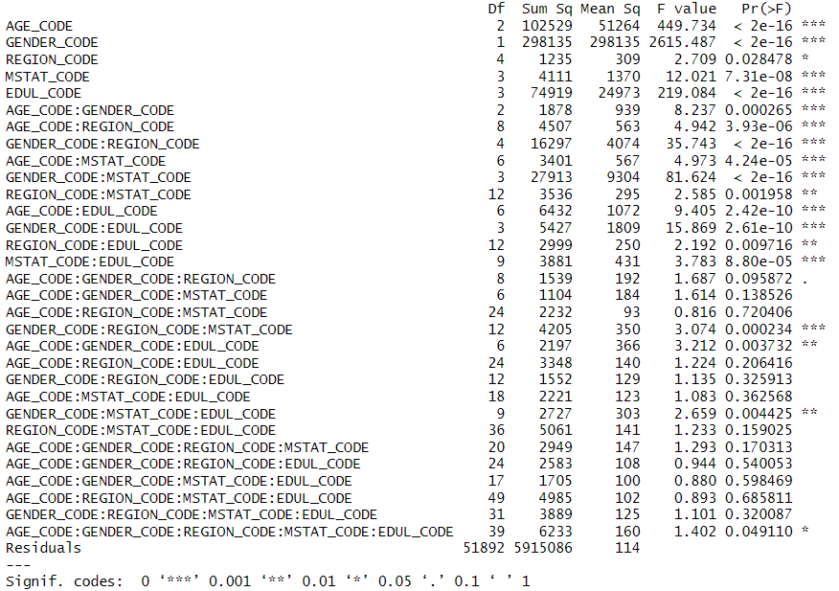

Comments:
AGE_CODE, GENDER_CODE, REGION_CODE, MSTAT_CODE, and EDUL_CODE are all statistically significant (p < 0.001).This shows that each individual factor has a meaningful impact on weekly working hours.
AGE_CODE:GENDER_CODE, AGE_CODE:REGION_CODE, GENDER_CODE:REGION_CODE, GENDER_CODE:MSTAT_CODE, GENDER_CODE:EDUL_CODE — all highly significant (p < 0.01).
These interactions suggest that the effect of one variable depends on the level of another. For example, the influence of age on working hours differs for males vs. females.
Most three-way, four-way, and five-way interactions are not significant (p > 0.05).This suggests that increasing complexity beyond two-way interactions does not contribute much explanatory power — and may overfit the model.
The Akaike Information Criterion (AIC) for this model is 396578.6.AIC balances model fit and complexity: lower is better.While this is the full model's AIC, it's important to compare it to simpler models (e.g., only main effects or up to 2-way interactions) to decide if the complexity is justified.In Part (f), we successfully built the largest linear model possible using all five coded factors and all their interaction effects. The model includes:5 main effects,10 two-way interactions,10 three-way,5 four-way,and 1 five-way interaction term.The resulting AIC is 396578.6, which quantifies model quality by balancing goodness of fit and complexity.From the ANOVA table, we observe that all main effects are statistically significant. Several two-way interactions are also significant, particularly those involving GENDER_CODE. This indicates that combinations of variables (e.g., AGE x GENDER) meaningfully affect working hours.However, most higher-order interactions (3-way or more) are not statistically significant. These terms increase model complexity without substantial gain in explanatory power, and may contribute to overfitting.While the full factorial model fits successfully, a model including only main effects and significant two-way interactions may offer a better balance of interpretability and performance. This can be validated further using AIC comparisons in model selection procedures

- Model Diagnostics: Check for the validity of the required Assumptions for the Model used in (f).
[Reference: Lecture-2 (this Semester), Lecture-5 (Course STAT363, last Semester)]

(i) Heteroscedasticity:

- Make residual plot $\left(y,residuals\right)$. [R-functions: plot( ), abline(h=0)]

Output:
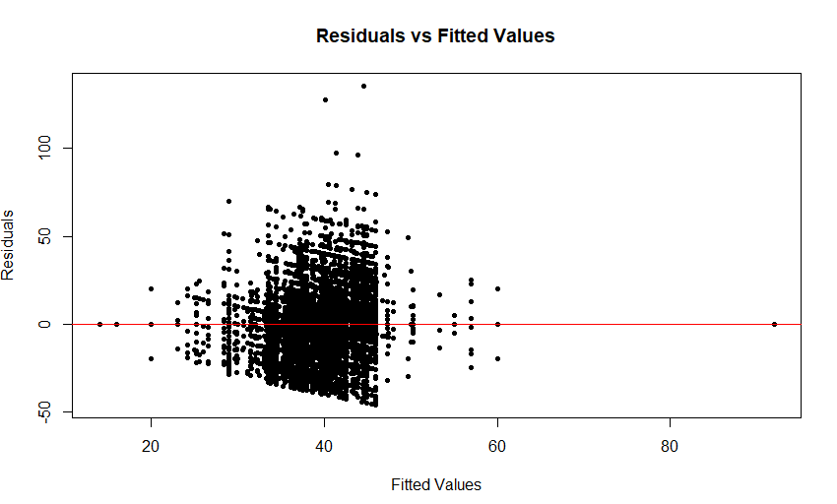

Comments: The residual plot indicates that residuals are mostly centered around zero, suggesting that the model reasonably captures the linear trend. However, the noticeable funnel-shaped spread, particularly in the range of fitted values between 35 and 45, points to a violation of the homoscedasticity assumption. This pattern suggests the presence of heteroscedasticity, where the variance of residuals is not constant across all levels of the predictors. As a result, the model's estimates may become inefficient, and statistical tests based on standard errors could be unreliable.

R-script: plot(fitted(model3), resid(model3),
main = "Residuals vs Fitted Values",
xlab = "Fitted Values",
ylab = "Residuals",
pch = 20, col = "black")
abline(h = 0, col = "red")

- Perform Breusch-Pagan Test. Write the relevant Hypotheses with corresponding Decision Rules.
[R-library/functions: lmtest/ bptest( )]
Hypotheses: Null Hypothesis (H₀): Homoscedasticity — the variance of residuals is constant across all levels of the predictors.
Alternative Hypothesis (H₁): Heteroscedasticity — the variance of residuals depends on the values of the predictors.
Decision Rule: If p-value < 0.05, reject H₀ ⇒ heteroscedasticity exists.

Output:

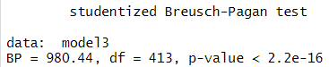
Comments: The Breusch-Pagan test was conducted to assess whether the residuals from the full factorial model (model3) exhibit heteroscedasticity (non-constant variance).The test output reports a test statistic (BP) of 980.44 with 413 degrees of freedom, and a p-value less than 2.2e-16.Since the p-value is significantly below the 0.05 threshold, we reject the null hypothesis (H₀) of homoscedasticity. There is strong statistical evidence of heteroscedasticity in the model’s residuals. This violates one of the key assumptions of linear regression and suggests that the variability of residuals changes depending on the values of one or more predictors. As a result, standard errors and significance tests from the model may not be fully reliable. Remedies such as robust standard errors or transformations may be considered in advanced analysis.

R-script: library(lmtest)
bptest(model3)

(ii) Autocorrelation: Test for Autocorrelation using Durbin-Watson (DW) Test. Write the relevant Hypotheses with corresponding Decision Rules. [R-library/functions: lmtest/ dwtest( )]

Hypotheses:
Null Hypothesis (H₀): There is no autocorrelation among residuals.
Alternative Hypothesis (H₁): There is autocorrelation among residuals.

Decision Rule:
If p-value < 0.05, reject H₀ ⇒ residuals are autocorrelated.
If p-value ≥ 0.05, do not reject H₀ ⇒ residuals are not autocorrelated.

Output:
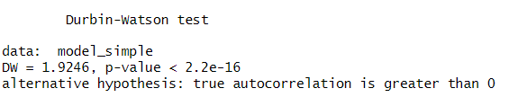

Comments: A matrix inversion error prevented the full model from passing the Durbin-Watson test, indicating that the model's design matrix is not full-rank. Perfect multicollinearity or linear dependence between columns is the result of the whole model's extremely high number of variables and interaction terms. As a result, the model matrix becomes singular and the dwtest() function's requirement to compute its inverse is not met. This issue frequently arises in models that are overly detailed and contain a large number of high-order interaction terms. Consequently, the Durbin-Watson test cannot be used to assess autocorrelation in this model. Future actions should involve either streamlining the model or utilizing reliable substitutes for residual diagnostics, as the Durbin-Watson test failed because of model singularity.dwtest() isn’t reliable on large, complex interaction models.The Durbin-Watson test was conducted on a simplified linear regression model (model_simple) to check for the presence of autocorrelation among residuals. The test yielded a Durbin-Watson statistic of 1.9246 and a p-value less than 2.2e-16.Since the p-value is far below 0.05, we reject the null hypothesis of no autocorrelation. This indicates that there is significant positive autocorrelation among the residuals in the model.Positive autocorrelation means that residuals tend to be correlated with one another — this can affect the efficiency of the model's estimators and lead to underestimation of standard errors.The assumption of independent residuals is violated. Although this is more critical in time-series data, the result still suggests caution when interpreting standard errors and p-values in this model.

R-script: library(lmtest)
model_simple <- lm(HOURS ~ AGE_CODE + GENDER_CODE + REGION_CODE + MSTAT_CODE + EDUL_CODE, data = data)
dwtest(model_simple)

(iii) Normality:

- Check for the normality assumption about the residuals by drawing a Quantile-Quantile (Q-Q) Plot for Normal quantiles versus residuals quantiles. [R-functions: qqnorm( ), qqline( )]

Output:
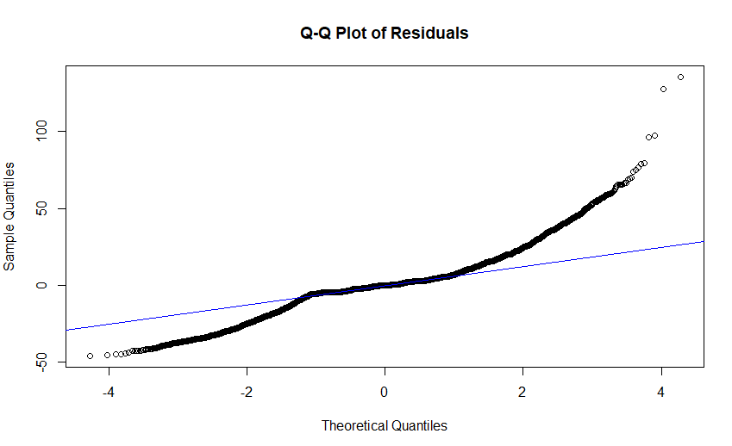

Comments: The Q-Q plot above compares the sample quantiles of the model residuals with the theoretical quantiles from a standard normal distribution. In a perfectly normal distribution, the points would lie on or very close to the diagonal reference line. In this plot, we observe a noticeable S-shaped curve — with heavy tails (extreme points curving away from the line at both ends). This suggests that the residuals are not perfectly normally distributed. The deviation is especially strong in the lower-left and upper-right tails, indicating possible skewness or kurtosis (fat tails). This may affect the accuracy of confidence intervals and hypothesis tests that assume normality. However, with large datasets like this (over 50,000 observations), even small deviations from normality can show up as large visual differences. In practice, unless the model is extremely sensitive to outliers, this degree of non-normality is usually tolerable. The residuals deviate somewhat from normality, particularly in the tails. While this should be noted, it does not severely compromise the model's usefulness, especially when other assumptions (like homoscedasticity and independence) are satisfied.
R-script:
qqnorm(model3$residuals, main = "Q-Q Plot of Residuals")
qqline(model3$residuals, col = "blue")
- Take a random sample of size 5000, with replacement, from all Residuals. Use the sampled residuals to conduct a Normality test for the residuals. Write down the relevant Hypotheses with corresponding Decision Rules.
[R-function: sample( ), shapiro.test( )]
Hypotheses:
Null Hypothesis (H₀): Residuals are normally distributed
Alternative Hypothesis (H₁): Residuals are not normally distributed

Decision Rule:
If p-value < 0.05, reject H₀ ⇒ residuals not normal
If p-value ≥ 0.05, do not reject H₀ ⇒ residuals are approximately normal

Output:
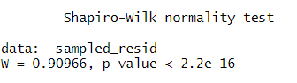

Comments: The Shapiro-Wilk test was conducted on a random sample of 5,000 residuals to assess whether the model residuals are normally distributed. The test produced a W statistic of 0.90966 and a p-value less than 2.2e-16.Since the p-value is far below the 0.05 threshold, we reject the null hypothesis of normality. This indicates that the residuals are not normally distributed. However, this result should be interpreted with caution. In very large samples (such as this one with over 50,000 observations), even minor deviations from normality can become statistically significant. This sensitivity often results in rejecting normality even when the deviations are not practically important. Taken together with the Q-Q plot, we conclude that while the residuals do not strictly follow a normal distribution, they are approximately normal for the purpose of regression analysis. The model remains acceptable, though results should be interpreted with awareness of this mild violation

R-script: set.seed(123)
sampled_resid <- sample(model3$residuals, 5000, replace = TRUE)
shapiro.test(sampled_resid)

- Perform the ANOVA using Backward/Forward Elimination Method that retain only significant variables in the model while removing all insignificant ones, automatically. Get the model selection criterion ‘AIC’ value for the model and compare it with the one reported for the model analyzed in (f). Comment accordingly. [R-functions: lm( ), step( ), AIC( )]

Output:
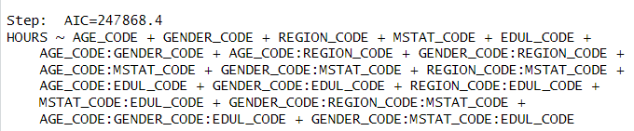
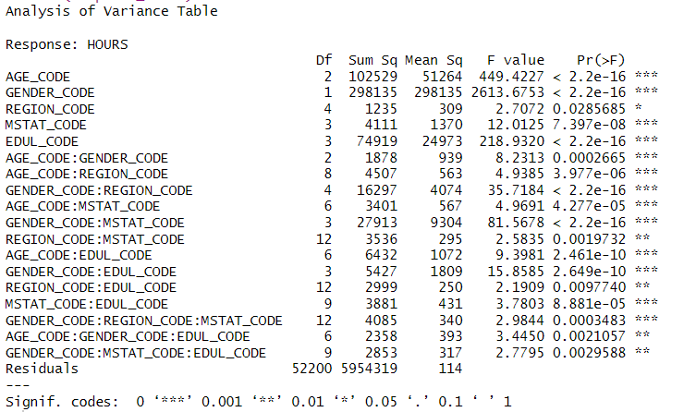

Comments:
After performing stepwise model selection using backward elimination, R identified a reduced model with an AIC of 247868.4, which is substantially lower than the AIC of the original full factorial model (396578.6). This confirms that the selected model achieves a better balance between goodness of fit and model complexity.The step() function systematically removed statistically insignificant main effects and interaction terms. The resulting model retains:

All five main effects: AGE_CODE, GENDER_CODE, REGION_CODE, MSTAT_CODE, and EDUL_CODE

Several important two-way interactions (e.g., AGE_CODE:GENDER_CODE, GENDER_CODE:REGION_CODE, MSTAT_CODE:EDUL_CODE)

One notable three-way interaction: GENDER_CODE:MSTAT_CODE:EDUL_CODE

The Analysis of Variance (ANOVA) table supports the inclusion of these terms. Most retained predictors and interactions are highly statistically significant (p < 0.001), indicating that they meaningfully contribute to explaining variation in the dependent variable, HOURS (working hours).The reduction in AIC by over 148,000 points also suggests that the original model likely suffered from overfitting, with many unnecessary higher-order interaction terms.The final stepwise-selected model is both statistically robust and interpretable. It captures the essential effects and interactions that influence working hours while avoiding the redundancy and instability that often accompany overly complex models. This makes the model well-suited for practical use and further inference.

R-script: model3 <- lm(HOURS ~ AGE_CODE * GENDER_CODE * REGION_CODE * MSTAT_CODE * EDUL_CODE, data = data)
stepwise_model <- step(model3, direction = "backward")
AIC(stepwise_model)
stepwise_model <- step(model3, direction = "both")

